Update a file through a Python algorithm

Project description
At my organization, access to restricted information is controlled using an allow list stored in a text file called "allow_list.txt". This file contains IP addresses that are permitted to access a secure subnetwork. We also maintain a remove list of IP addresses that should no longer have access—usually because an employee has changed roles or left the company.
To streamline this update process, I created a Python algorithm that automatically removes any IP addresses from the allow list that appear in the remove list. This helps maintain security and ensures that only the correct users retain access.

Open the file that contains the allow list
To begin the algorithm, I assigned the filename to a variable called import_file:
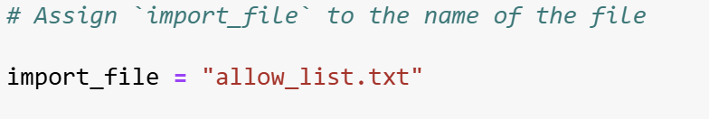
Then, I created a with statement using the open() function in read mode:
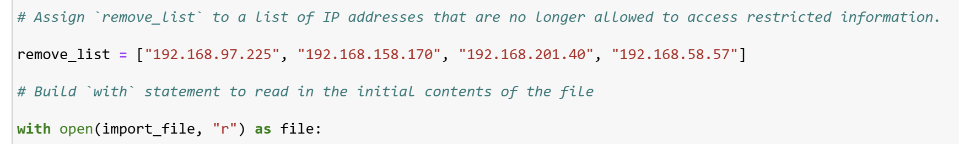
This line opens the allow list file so that its contents can be accessed.
The with statement ensures the file automatically closes after processing.
Inside the parentheses, the first argument specifies the file, and "r" indicates read mode.
The as file keyword assigns the opened file object to the variable file, allowing me to use it inside the with block.

Read the file contents
Inside the with block, I used the .read() method to convert the entire file into a single string:
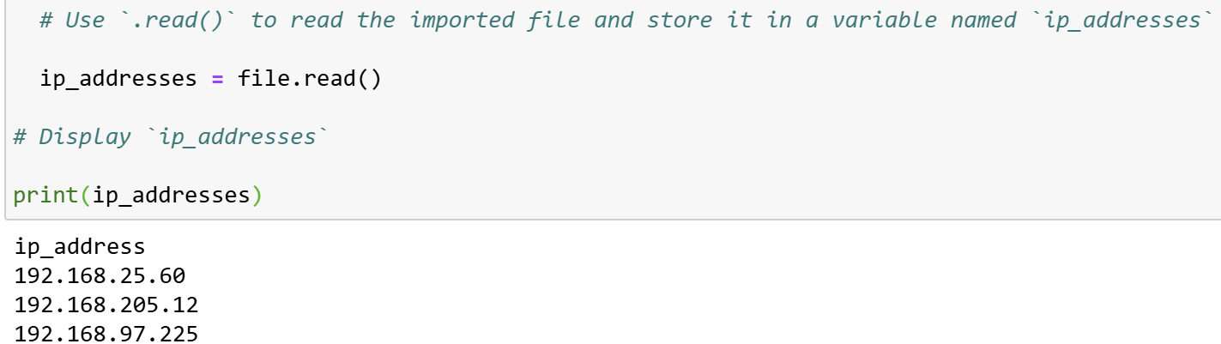
The .read() method extracts all of the file’s text at once and stores it in the variable ip_addresses.
Reading the file into a string makes it easier to process and transform the data during the later steps.

Convert the string into a list
Next, I needed the allow list in list format so I could remove specific IP addresses individually.
To do this, I used the .split() method:
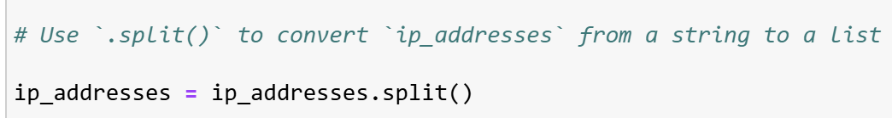
The .split() method separates the long string into a list by splitting at whitespace boundaries.
Each IP address becomes its own list element.
This format allows me to easily compare and remove entries.

Iterate through the remove list
To identify which IP addresses must be removed, I created a list called remove_list containing the restricted IPs.
Then, I built a for loop to iterate through each element of the allow list:
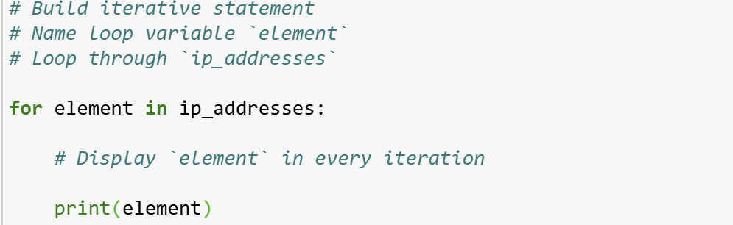
For keyword begins a loop, element becomes the loop variable, and in ip_addresses ensures the loop cycles through every IP address.
Printing each element helped confirm the loop was working correctly.

Remove IP addresses that are on the remove list
To remove matches, I added a conditional statement inside the loop:
if element in remove_list:
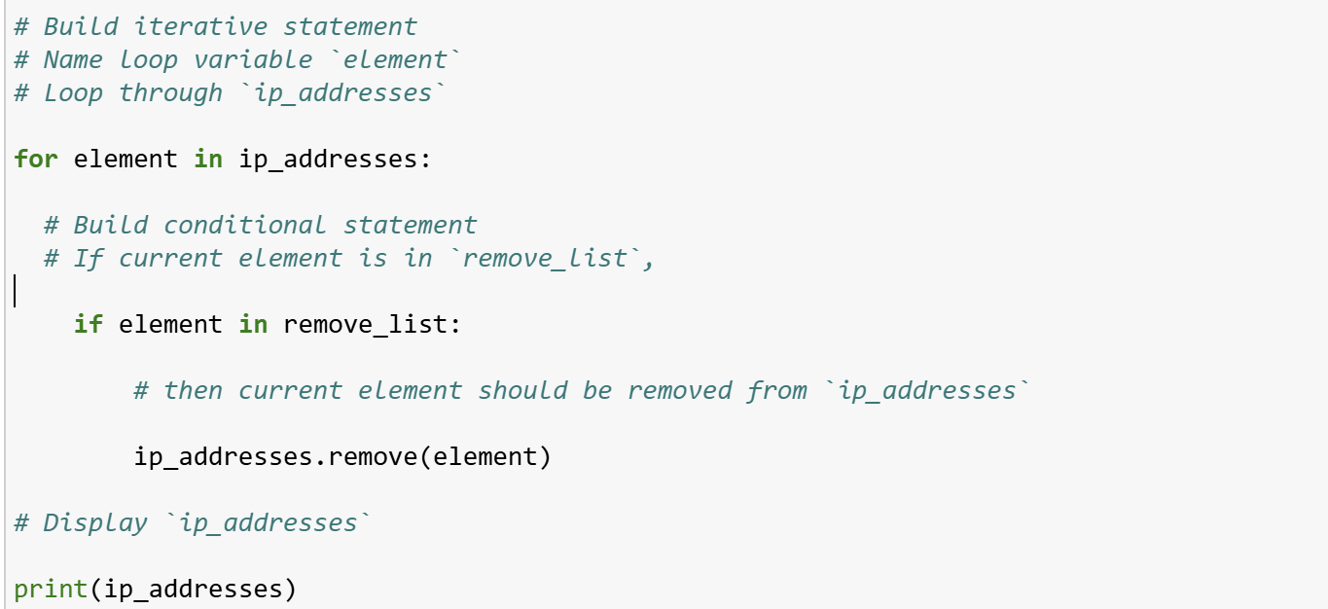The purpose of the conditional is to check whether the current element appears in the remove list.
If it does, the .remove() method deletes it from the ip_addresses list.
Because each IP address in the allow list is unique, .remove() is safe to use without handling duplicates.

Update the file with the revised list of IP addresses
After removing the unwanted IP addresses, I converted the updated list back into a string using the .join() method:
The "\n" separator places each IP address on a new line, restoring the file’s original structure.
Next, I used another with statement to open the file again—this time in write mode:
with open(import_file, "w") as file:
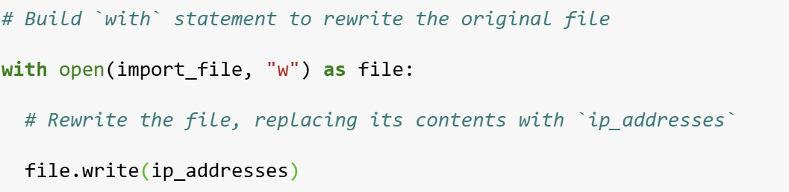
Using "w" overwrote the file with the new, cleaned-up list.
The .write() method replaces all existing content with the updated string stored in ip_addresses.
This completes the algorithm and ensures only the correct IP addresses remain in the allow list.

Summary
I built a Python algorithm that automatically updates the organization’s "allow_list.txt" file by removing any IP addresses that appear in a predefined remove list. The process involved opening and reading the allow list file, converting its string contents into a list, iterating through the list, and applying a conditional statement to remove matching IPs. After cleaning the data, I used the .join() method to convert the list back into a properly formatted string and rewrote the file using a with statement and the .write() function. This automated approach improves accuracy and efficiency when managing access permissions.

